

Department of

Artificial Intelligence & Data Science Engineering

Academic Year 2022-23

IOT Based Gas Leakage Detection System

Guided by –

Prof. Sarika Yuvraj Mane

Submitted By:

Yash Narendra Sawalkar (63)

Shivam Nitin Solanki (67)

CERTIFICATE

This is to certify that the project titled “IOT Based Gas Leakage Detection System” has been completed under our supervision and guidance, by the following students:

Shivam Nitin Solanki

Yash Narendra Sawalkar

In the partial fulfillment of PBL Mini Project of Semester V in the Department of Artificial Intelligence & Data Science, during the academic year 2022-2023. The said work has been assessed and is found to be satisfactory.

____________________                                                                           ______________________

Prof. Sarika Yuvraj Mane (External Examiner)

(Internal Guide)

________________________                                                                             ___________________

 Prof. Dr. Milind Nemade                         Dr. Suresh. Ukarande

 (Head of Department)                                                                                           (Principal KJSIEIT)

College Seal

ACKNOWLEDGEMENT

First and foremost, as a team, we would like to display our deepest gratitude to our project guide Prof. Sarika Yuvraj Mane who gave us a golden opportunity to work on the project titled “IOT Based Gas Leakage Detection System”. The amount of ideas, motivation and guidance provided by our guide has been monumental for completing our project. The quality of mentoring provided by our guide has resulted in bringing out the best researcher in each one of us.

It is also our humble opportunity to thank our college—K J Somaiya Institute of Engineering & Information Technology & its authorities—Dr. Suresh Ukarande, Principal, for providing invaluable resources—the library books, the recent infrastructural resources. A sincere thank you gesture to our Head of the Department Dr. Milind Nemade of AI_DS branch for extending the departmental support with relevant guidance on all occasions.

Besides, we would like to thank all the faculty and staff who helped us by giving us advice and providing the equipment which we needed for completion of this project. On the same note, we wish to thank our fellow classmates as the idea of preparing an insightful presentation on “IOT Based Gas Leakage Detection System” was inspired by a few creative team members. We would also like to thank our friends for providing us with information regarding different surveying websites. We would like to express our heartfelt gratitude to our parents who constantly supported us throughout our journey.

ABSTRACT

Liquefied Petroleum Gas (LPG) is a main source of fuel, especially in urban areas because it is clean compared to firewood and charcoal. Gas leakage is a major problem in the industrial sector, residential premises, etc. Nowadays, home security has become a major issue because of increasing gas leakage. Gas leakage is a source of great anxiety with ateliers, residential areas and vehicles like Compressed Natural Gas (CNG), buses, and cars which are run on gas power. One of the preventive methods to stop accidents associated with the gas leakage is to install a gas leakage detection kit at vulnerable places. The aim of this paper is to propose and discuss a design of a gas leakage detection system that can automatically detect, alert and control gas leakage. This proposed system also includes an alerting system for the users. The system is based on a sensor that easily detects a gas leakage.

Internet of Things aim towards making life simpler by automating every small task around us. As much is IoT helping in automating tasks, the benefits of IoT can also be extended for enhancing the existing safety standards. Safety, the elementary concern of any project, has not been left untouched by IoT. Gas Leakages in open or closed areas can prove to be dangerous and lethal. The traditional Gas Leakage Detector Systems though have great precision, fail to acknowledge a few factors in the field of alerting the people about the leakage. Therefore, we have used the IoT technology to make a Gas Leakage Detector for society which having Smart Alerting techniques involving sending email to the concerned authority and an ability performing data analytics on sensor readings. Our main aim is to proposing the gas leakage system for society where each flat have gas leakage detector hardware. This will detect the harmful gases in environment and alerting to the society member through alarm and sending notification.

**Keywords:** LPG (liquefied petroleum gas); gas sensor MQ 2; buzzer (alarm); LED (light).

**INDEX**

|  |  |  |
| --- | --- | --- |
| **Sr.**  **No.** | **Contents** | **Page No.** |
| 1. | Certificate | i |
| 2. | Acknowledgement | ii |
| 3. | Abstract | iii |
| 4. | Introduction | 1 |
| 5. | Problem Statement | 2 |
| 6. | Project Objectives | 3 |
| 7. | Literature Survey | 4 |
| 8. | Gantt Chart | 9 |
| 9. | Proposed System | 10 |
| 10. | Software & Hardware Requirements | 12 |
| 11. | System Design | 17 |
| 12. | System Implementation | 19 |
| 13. | Results | 19 |
| 14. | Conclusion | 21 |
| 15. | Future Scope | 22 |
| 16. | References | 23 |

1. **INTRODUCTION**

Internet of Things aim towards making life simpler by automating every small task around us. As much is IoT helping in automating tasks, the benefits of IoT can also be extended for enhancing the existing safety standards. Safety has always been an important criterion while designing home, buildings, industries as well as cities. The increased concentration of certain gases in the atmosphere can prove to be extremely dangerous. These gases might be flammable at certain temperature and humidity conditions, toxic after exceeding the specified concentrations limits or even a contributing factor in the air pollution of an area leading to problems such as smog and reduced visibility which can in turn cause severe accidents and also have adverse effect on the health of people.

Most of the societies have fire safety mechanism. But it can use after the fire exists. In order to have a control over such conditions we proposed system that uses sensors which is capable of detecting the gases such as LPG, CO2, CO and CH4. This system will not only able to detect the leakage of gas but also alerting through audible alarms. Presence of excess amounts of harmful gases in environment then this system can notify the user. System can notify to society admin about the condition before mishap takes place through a message.

System consists of gas detector sensors, Arduino board, ESP8266 and Cloud Server(Blynk). One Society authority person can register the all-flat member user to our system. Society admin can add the details of per flat user such as user name, mobile number, per user flat sensor details information. Society admin can configure the threshold value of each sensor. System hardware can be deployed on each flat. Sensors can sense the value per time. System can send the values to cloud server. Server can Check that the sensor values was existed the threshold value. If sensor value can cross the limit the server can send the command to hardware for buzzing the alarm.[3] Server also sends the notification message to user.

Gas leakage is a serious problem and nowadays it is observed in many places like residences, industries, and vehicles like Compressed Natural Gas (CNG), buses, cars, etc. It is noticed that due to gas leakage, dangerous accidents occur. The Liquefied petroleum gas (LPG), or propane, is a flammable mixture of hydrocarbon gases used as fuel in many applications like homes, hostels, industries, automobiles, and vehicles because of its desirable properties which include high calorific value, less smoke, less soot, and meager harm to the environment. Liquid petroleum gas (LPG) is highly inflammable and can burn even at some distance from the source of leakage. This energy source is primarily composed of propane and butane which are highly flammable chemical compounds. These gases can catch fire easily. In homes, LPG is used mainly for cooking purposes. When a leak occurs, the leaked gases may lead to an explosion. Gas leakage leads to various accidents resulting in both material loss and human injuries. Home fires have been occurring frequently and the threat to human lives and properties has been growing in recent years. The risks of explosion, fire, suffocation are based on their physical properties such toxicity, flammability, etc. The number of deaths due to the explosion of gas cylinders has been increasing in recent years. The Bhopal gas tragedy is an example of accidents due to gas leakage.

The reason for such explosions is due to substandard cylinders, old valves, no regular checking of gas cylinders, worn out regulators and a lack of awareness of handling gas cylinders. Therefore, the gas leakage should be detected and controlled to protect people from danger. An odorant such as ethane thiol is added to LPG, so that leaks can be detected easily by most people. However, some people who have a reduced sense of smell may not be able to rely upon this inherent safety mechanism. A gas leakage detector becomes vital and helps to protect people from the dangers of gas leakage. In this system, the gas leakage is detected. The level of LPG in cylinder is also continuously monitored. In the existing method, different gas sensing technology is used.

**PROBLEM STATEMENT**

Liquid Petroleum Gas (LPG) is a highly flammable chemical that consists of mixture of propane and butane. LPG is used for cooking at home, restaurant, and certain use for industry. They have certain weaknesses that make the gas leakage occur. The leakage of gases only can be detected by human nearby and if there are no human nearby, it cannot be detected. But sometimes it cannot be detected by human that has a low sense of smell. Thus, this system will help to detect the presence of gas leakage.

Furthermore, gas leakage can cause fire that will lead to serious injury or death and it also can destroy human properties. This system was developed by using IoT to give real-time response to the user and the nearest fire station.

**PROJECT OBJECTIVES**

* To build a prototype that can detect the gas leakage which will be uploaded on the cloud for cloud computation.
* To determine the level of gas leakage and alert the concerned person depending upon the gas leakage via Blynk Cloud.

**LITERATURE SURVEY**

1. Smart Gas Level Monitoring, Booking & Gas Leakage

This project proposed the most common problem experienced in our day- to- day lives that is regarding GAS container going empty. We bring this paper to create awareness about the reducing weight of the gas in the container, and to place a gas order using IOT. The gas booking/order is being done with the help IOT and that the continuous weight measurement is done using a load cell which is interfaced with a Microcontroller (to compare with an ideal value). For ease it is even has been added with an RF TX & Rx module which will give the same information. When it comes it to security of the kit as well as gas container, we have an MQ-2(gas sensor), LM 35(temperature sensor), which will detect the surrounding environment for any chance of error. Whenever any change is subjected in any of the sensors (load cell, LM35, Mq-2) a siren (60db) is triggered [1].

1. LM 35 (temp, sensor)

For the sensors, if any fire is to be happened then the temperature sensor will sense an high change(positive change) in temperature and will send an pulse to microcontroller which intern will send an update to the internet through IoT, and as well it will trigger an siren alarm in the RF Rx kit(sub board)[2].

1. MQ-2 (Gas Sensor)

MQ 2 sensor is basically an LPG (liquefied petroleum gas) which is composed of propane & butane, so when a gas leakage is sensed by the sensor it will send an high pulse to the Mc which will update it in the IoT, and even[5] an buzzer is heard in the RF Rx kit. And the problem can be sorted & solved. Thus the overall components & sensors play role in the paper as explained above.

1. Gas Leak Detection and Localization System through Wireless Sensor Networks

In this project we proposed a prototype of a Wireless Sensor Network (WSN) to monitor and locate gas leaks of a complex indoor environment. Specifically, a mobile node is moving inside a building to monitor any leakage of carbon dioxide (CO2), supporting and displaying the level and the location of the leakage. Throughout the demonstration, the technological advantages of cognitive networking along with multichip routing are explored.

1. Cloud Connected Smart Gas Leakage Detection and Safety Precaution System

The project design and develop a cloud connected smart LPG gas cylinder platform, acting as a safety device for detecting LPG gas leak at low levels to avoid any possible accidents. It is also capable of sensing fire breakout in the area and weight of the gas in order to provide real time monitoring and alert over Internet. If an abnormal condition is detected, the device sends an alert to the smartphone app of the user and also generates an alert e-mail to other authorities. In addition to this upon detecting a gas leakage or a fire breakout, the device automatically takes safety precautionary measures, like gas valve closing, ventilation opening, fire sprinkler activation and home electrical power supply cut-off. The device connects to the internet via Wi-Fi and thus increasing the mobility of the platform within the premises of the house. A Wi-Fi capable ARM Cortex-M4 microcontroller is used to implement the system. This device offers a complete, low cost, powerful and user friendly way of real-time monitoring and remote control of gas leakages and prevention mechanisms in household and industrial areas [2].

Features of system hardware:

1. Live-Monitoring and Control

The smartphone app can show the amount of LPG gas remaining, present room temperature other device status. These data are updated every few seconds providing real-time live monitoring. In addition to this, the actuators connected on the device can be controlled from the smartphone app giving additional benefits for the user.

1. On-Demand Automatic Reordering Facility

If the device is configured in automatic reordering mode, whenever the gas level comes below a certain threshold, the device automatically sends a gas cylinder requesting e-mail to the gas vendor or gas distributor. The user must save the e-mail address of the gas distributor before enabling this feature.

1. Low Weight Alert

Every time when a new gas cylinder is delivered, the user must press a button on the device which starts the process of measuring the weight of the cylinder and if it detects low weight cylinder, which means a low fuel content, it will immediately alert the user smartphone app about this as well as send an e-mail alert to the gas agency company to register this case. This is a useful application in finding and avoiding a low weight gas cylinder at the time of delivery.

1. Actuators

A servo motor is used to control the gas valve position, whereas DC fan motor mechanism acts like a ventilation/exhaust fan [4]. Another DC electrical motor will do the work of a fire sprinkler motor. All these motors are controlled using appropriate PWM signal generation. An AC relay circuitry is used cut-off the mains electrical supply.

1. Local Audio Alarm

A loud beep alarm sound is generated intermittently to alert the neighboring people.

1. Device User Interface Notification

LED’s are used to indicate Wi-Fi provisioning and cloud server connection status.[3]

1. Gas Leakage Detection and Smart Alerting and Prediction Using IoT

IoT is an expanding network of physical devices that are linked with different types of sensors and with the help of connectivity to the internet; they are able to exchange data. Through IoT, internet has now extended its roots to almost every possible thing present around us and is no more limited to our personal computers and mobile phones. Safety, the elementary concern of any project, has not been left untouched by IoT. Gas Leakages in open or closed areas can prove to be dangerous and lethal. The traditional Gas Leakage Detector Systems though have great precision, fail to acknowledge a few factors in the field of alerting the people about the leakage. Therefore, we have used the IoT technology to make a Gas Leakage Detector having Smart Alerting techniques involving calling, sending text message and an e-mail to the concerned authority and an ability to predict hazardous situation so that people could be made aware in advance by performing data analytics on sensor readings. Internet of Things is being used everywhere in order to ease our daily tasks and improve the quality of life.

1. Applications of Wireless Sensor Networks in the Oil, Gas and Resources Industries

The paper provides a study on the use of Wireless Sensor Networks (WSNs) in refineries, petrochemicals, underwater development facilities, and oil and gas platforms. The work focuses on networks that monitor the production process, to either prevent or detect health and safety issues or to enhance production. WSN applications offer great opportunities for production optimization where the use of wired counterparts may prove to be prohibitive. They can be used to remotely monitor pipelines, natural gas leaks, corrosion, H2S, equipment condition, and real-time reservoir status. Data gathered by such devices enables new insights into plant operation and innovative solutions that aids the oil, gas and resources industries in improving platform safety, optimizing operations, preventing problems, tolerating errors, and reducing operating costs. In this paper, we survey a number of WSN applications in oil, gas and resources industry operations.[5]

1. GSM Based Gas Leakage Detection System

Gas leakage is a major problem with industrial sector, residential premises and gas-powered vehicles like CNG (compressed natural gas) buses, cars. One of the preventive methods to stop accident associated with the gas leakage is to install gas leakage detection kit at vulnerable places. The aim of this paper is to present such a design that can automatically detect and stop gas leakage in vulnerable premises. In particular gas sensor has been used which has high sensitivity for propane (C3H8) and butane (C4H10). Gas leakage system consists of GSM (Global System for mobile communications) module, which warns by sending SMS. However, the former gas leakage system cannot react in time. This project provides the design approach on both software and hardware. Gas leakage detection is not only important but stopping leakage is equally essential. This paper provides a cost effective and highly accurate system, which not only detect gas leakage but also alert (Beep) and turn off main power and gas supplies, and send an SMS. GSM module is used which alert the user by sending an SMS. In order to provide high accuracy gas sensor MQ-6 has been used.

1. A UAV System for Autonomous Target Detection and Gas Sensing

Monitoring of environmental gases is a demanding task that can require long periods of observation and large numbers of sensors. Unmanned Aerial Vehicles (UAVs) presently represent a suitable alternative to monitor large, remote, and difficult to access areas. Due to the wide range and diversity of shape and size, UAVs now possess the capability of carrying specialized sensor modules that can accurately monitor gas concentrations. This project describes the design and flight testing of a UAV which carries an on-board camera and a carbon dioxide gas sensor and is capable of autonomous gas sensing while simultaneously visually detecting predefined targets placed at locations inside a room. The detection system autonomously navigates around the flight area using a waypoint navigation system and hovers for 10 seconds once the target has been visually [6] identified taking Air Quality (AQ) samples as it does so. Laboratory, bench and field test results demonstrate the capability of the UAV to detect targets placed in a room and analyze the air quality of samples taken during flight above the target. The data collected during the flight is transmitted, in real time, back to a Ground Control Station (GCS) for visualization and analysis, where 3D mapping of the target location and gas concentration is presented via a web interface. Test cases verify the capability of the subsystem’s integration and the operation of the UAV system as a whole. The image processing algorithm used for the target detection, based on a cascade method, proved to be dependent on the frame transmission rates, which can make the software considerably slower. The developed system provides an effective monitoring system and can be used in a wide range of applications such as gas leaks, fires, and mining applications and if converted for use in an outdoor environment, applications such as agriculture biomass burning emissions and chemical and biological agent detection studies. The system could be used in conjunction with ground sensors and integrated into an extensive gas monitoring system.

1. Context-Adaptive Multimodal Wireless Sensor Network for Energy-Efficient Gas Monitoring

We proposed a wireless sensor network (WSN) for monitoring indoor air quality, which is crucial for people’s com-fort, health, and safety because they spend a large percentage of time in indoor environments. A major concern in such networks is energy efficiency because gas sensors are power-hungry, and the sensor node must operate unattended for several years on a battery power supply. A system with aggressive energy management at the sensor level, node level, and network level is presented. The node is designed with very low sleep current consumption (only 8 µA), and it contains a metal oxide semiconductor gas sensor and a pyroelectric infrared (PIR) sensor. Furthermore, the network is multimodal; it exploits information from auxiliary sensors, such as PIR sensors about the presence of people and from the neighbor nodes about gas concentration to modify the behavior of the node and the measuring frequency of the gas concentration. In this way, we reduce the nodes’ activity and energy requirements, while simultaneously providing a reliable service. To evaluate our approach and the benefits of the context-aware adaptive sampling, we simulate an application scenario which demonstrates a significant lifetime extension (several years) compared to the continuously-driven gas sensor. In March 2012, we deployed the WSN with 36 nodes in a four-story building and by now the performance has confirmed models and expectations.

1. The Application of a Continuous Leak Detection System to Pipelines and Associated Equipment

In recent year the problem of leak detection in pipelines, tanks, and process vessels has been the focus of many man-hours of effort. Some examples of leaks occurring in pipelines, an overview of classical leak detection systems, and the engineering basis of a new type of detector system are examined. This system is a flexible hydrocarbon sensing cable that can be installed dong pipelines, in double containment tanks and piping, or in trenches to detect and locate leaks of common industrial hydrocarbon solvents or fuels while ignoring the presence of water. The simple electrical circuit is also described, which locates and detects a leak anywhere along the length of the sensor. The current major method of leak detection is the compensated volume balance method. This method essentially measures the “volume in” and subtracts the “volume out”. There are meters that are guaranteed repeatable to within -05 percent. An alarm will sound when there is a significant difference in volume. The pump station management will determine if the difference in the two measured volumes is the result of an operational change or if the pipe is leaking. Operational changes can result from a change in product grade, change of pumps or pumping pressure, or a change in temperature because of storage tank changes [9].

**GANTT CHART**



**PROPOSED SYSTEM**

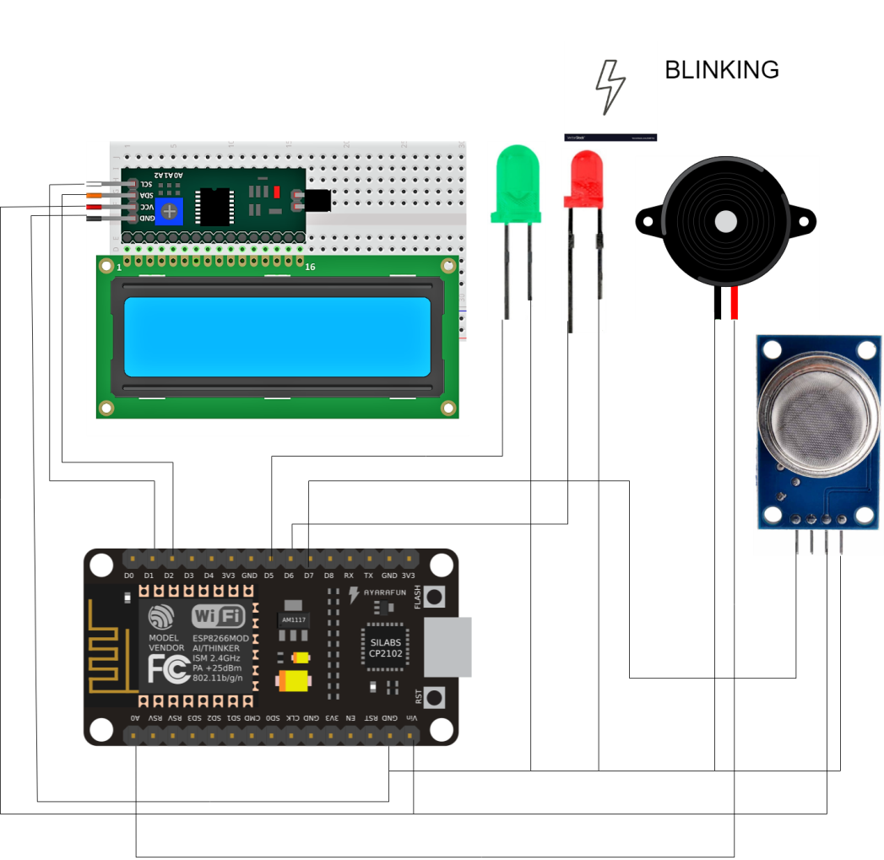

Figure 1: Proposed System (Whole System Overview)

**SOFTWARE & HARDWARE REQUIREMENTS**

1. Software Requirements:
2. Arduino IDE 2.0.1



Figure 2: Arduino Logo

The Arduino IDE 2.0 is an open-source project. It is a big step from its sturdy predecessor, Arduino IDE 1.x, and comes with revamped UI, improved board & library manager, debugger, autocomplete feature and much more.

1. Blynk 2.0



Figure 3: Blynk Logo

Blynk platform powers low-batch manufacturers of smart home products, complex HVAC systems, agricultural equipment, and everyone in between. These companies build branded apps with no code and get the full back-end IoT infrastructure through one subscription.

1. Hardware Requirements:
2. Node MCU

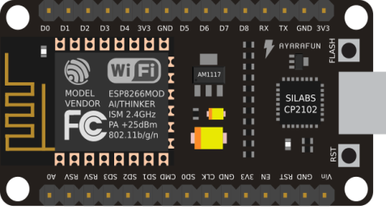

Figure 4: Node MCU

Node MCU is a low-cost open source IoT platform. It initially included firmware which runs on the ESP8266 Wi-Fi SoC from Espressif Systems, and hardware which was based on the ESP-12 module. Later, support for the ESP32 32-bit MCU was added.



1. Bread-Board

Figure 5: Bread-Board

A breadboard, solderless breadboard, or protoboard is a construction base used to build semi-permanent prototypes of electronic circuits.

1. LCD Display (16*2)

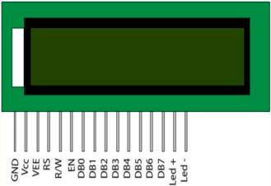

Figure 6: 16x2 LCD

This 16x2 LCD pinout diagram can help you customize the output to display characters, interfacing and so much more.

1. Buzzer



Figure 7: Buzzer

A buzzer or beeper is an [audio](https://en.wikipedia.org/wiki/Sound) signaling device, which may be [mechanical](https://en.wikipedia.org/wiki/Machine), [electromechanical](https://en.wikipedia.org/wiki/Electromechanics). Typical uses of buzzers and beepers include [alarm devices](https://en.wikipedia.org/wiki/Alarm_devices), [timers](https://en.wikipedia.org/wiki/Timer), [train](https://en.wikipedia.org/wiki/Train) and confirmation of user input such as a mouse click or keystroke.

1. Gas Sensor (MQ-2)



Figure 8:MQ2 Sensor

The MQ2 is a heater-driven sensor. It is therefore covered with two layers of fine stainless-steel mesh known as an “anti-explosion network”. It ensures that the heater element inside the sensor does not cause an explosion because we are sensing flammable gasses. It also protects the sensor and filters out suspended particles, allowing only gaseous elements to pass through the chamber. A copper-plated clamping ring secures the mesh to the rest of the body.

1. Jumper Wires

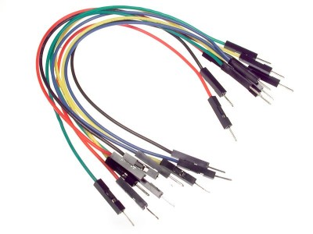

Figure 9: Jumper Wires

Jumper wires are used for making connections between items on your breadboard and your Arduino’s header pins. Use them to wire up all your circuits!

1. I2C Module

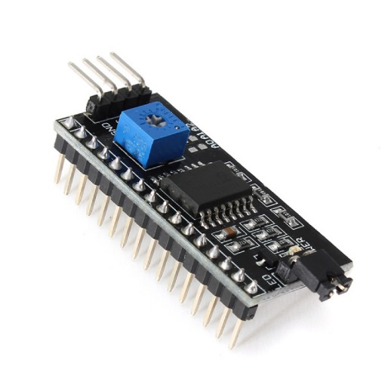

Figure 10: I2C Module

I2C Module has a inbuilt PCF8574 I2C chip that converts I2C serial data to parallel data for the LCD display. These modules are currently supplied with a default I2C address of either 0x27 or 0x3F. To determine which version, you have checked the black I2C adaptor board on the underside of the module. If there 3 sets of pads labelled A0, A1, & A2 then the default address will be 0x3F. If there are no pads the default address will be 0x27.

1. Led Lights



Light-emitting diode (LED) is a widely used standard source of light in electrical equipment. It has a wide range of applications ranging from your mobile phone to large advertising billboards. They mostly find applications in devices that show the time and display different types of data.

**SYSTEM DESIGN**

Flow diagram depicting complete mechanism of the system

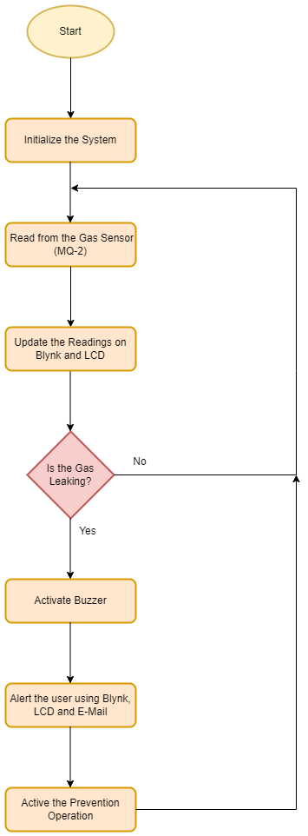

Live tracking with Blynk

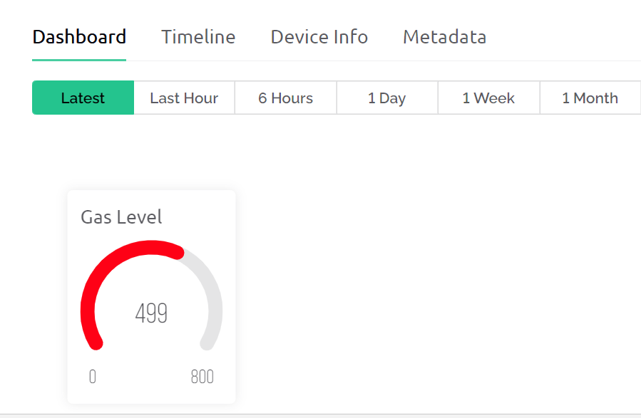

With the help of Blynk, live measurement of the sensor is obtained to the user.

Actual physical representation



**SYSTEM IMPLEMENTATION & RESULTS**

This system is based on Node MCUR3 and MQ-2 gas sensor. When the sensor detects gas in atmosphere, it will give a digital output of 1 and if gas is not detected the sensor will give a digital output of 0. Node MCU will take the sensor output as the digital input. If sensor output is high, then the buzzer will start tuning and the LCD will show that “Gas detected: Yes”. If sensor output is low then the buzzer will not be tuning, LCD will show that “Gas detected: No”. The detector incorporates a MQ-2 sensor (with gas detection range of 300–10,000 ppm) as the LPG gas sensor, PIC16F690 microcontroller as the control unit, LCD for displaying gas concentration, a buzzer as an alarm and a number of LEDs to indicate the gas leakage status. The microcontroller senses the presence of a gas when the voltages signal from the MQ-2 sensor goes beyond a certain level and gives an audiovisual alarm

1. Reading normal

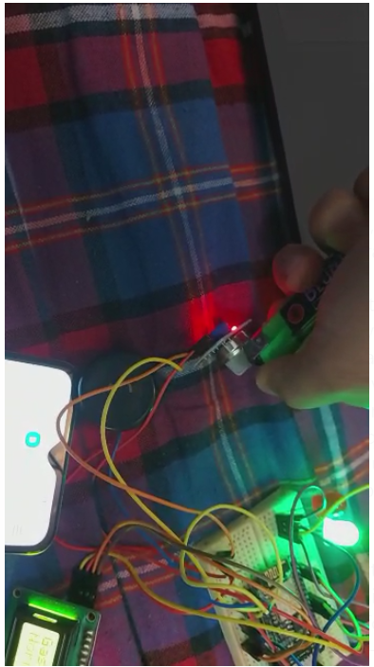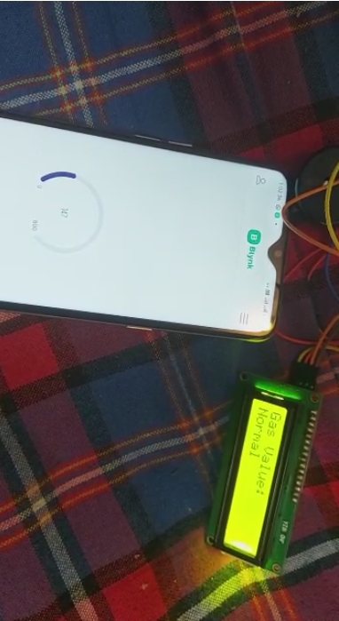

2. Simulation of gas leakage

3. Gas is detected, the buzzer is on and red lights are blinking

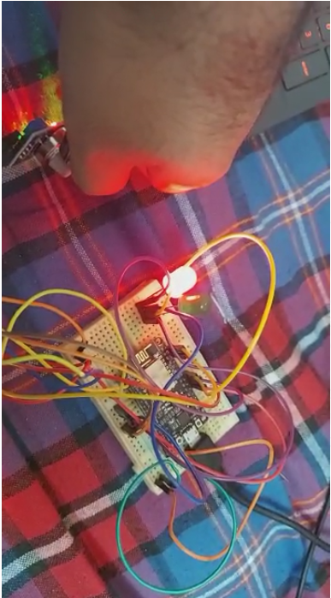

4. Warning message received on Blink along also an e-mail.



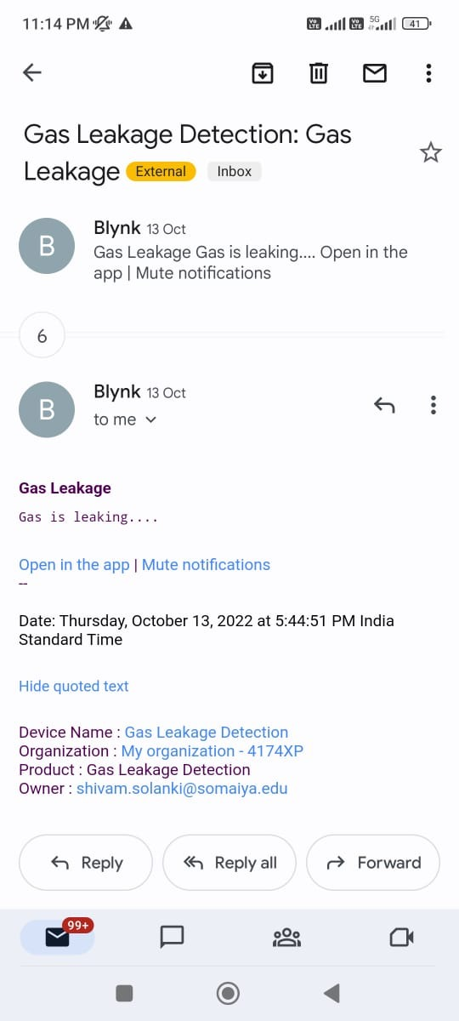

**FUTURE SCOPE**

This can be upgraded based on the needs of a particular application domain. This can also be improved by using more advanced sensors and hardware.

The design of a sensor-based automatic gas leakage detector with an alert and control system has been proposed and discussed in this paper. This is a low-cost, low power, lightweight, portable, safe, user friendly, efficient, multi featured and simple system device for detecting gas. Gas leakage detection will not only provide us with significance in the health department but it will also lead to raise our economy, because when gas leaks it not only contaminates the atmosphere but also wastage of gases will hurt our economy. The proposed system will cost only USD 10 which is easily affordable even for poor people. In the open literatures it is noticed that much work has not been done for a smart gas detection system. In future, more advanced features will be integrated with this system which will provide users with more safety and relaxation. The proliferation of handheld devices has led to developments in the field of smart gas sensors, which has considerably widened their scope of application. The need for ensuring safety in workplaces is expected to be the key driving force for the market over the coming years.

**CONCLUSION**

After all the data had been gathered, analyzed and processed, the proponents arrived at the succeeding conclusion. Therefore, the researchers concluded that the “IOT Based Gas Leakage Detection System” will help a lot in terms of preventing any danger caused by gas leakage and useful as part of safety to avoid the gas leak that can cause harmful result. It will also improve the safety of all users of Liquefied Petroleum Gas by providing alerts in form of sounds and emails in case of gas leakage.

After this project performance, can conclude that detection of the LPG gas leakage is incredible in the project system. Applicable usefully in the industrial and domestic purpose. In danger situations we are able to save the life by using this system. An alert is indicated by the GSM module. A sensor node senses gas like CO2, oxygen, propane. The estimated range of transmission and consumption of power is obtained and actions can be made based on that accordingly.

**REFERENCES**

[1] Kumar Keshamoni and Sabbani Hemanth. "Smart Gas Level Monitoring, Booking & Gas Leakage Detector over IoT " International Advance Computing Conference IEEE, 2017.

[2] Petros Spachos , Liang Song and Dimitrios Hatzinakos. "Gas Leak Detection and Localization System Through Wireless Sensor Networks" The 11th Annual IEEE Consumer Communications and Networking Conference - Demos. IEEE, 2014.

[3] Babuprasanth.V. “Cloud Connected Smart Gas Leakage Detection And Safety Precaution System" International Journal of MC Square Scientific Research Vol.6, No.1 Nov 2014.

[4] Asmita Varma, Prabhakar S, Kayalvizhi Jayavel. “Gas Leakage Detection and Smart Alerting and Prediction Using IoT." Internet of Things and Applications (IOTA), International Conference on. IEEE, 2017.

[5] Mohammad Reza Akhondi, Alex Talevski, Simon Carlsen, Stig Petersen. “Applications of Wireless Sensor Networks In the Oil, Gas And Resources Industries." International Conference On Advanced Information Networking And Applications, IEEE 2010.

[6] Ashish Shrivastava, Ratnesh Prabhaker, Rajeev Kumar and Rahul Verma “Gsm Based Gas Leakage Detection System." International Journal Of Technical Research And Applications EISSN: 2320-8163.

[7] Tyler Kersnovski, Felipe Gonzalez, Kye Morton. "A UAV System For Autonomous Target Detection And Gas Sensing." Yellowstone Conference Center, Big Sky, Montana, IEEE 2017.

[8] Vana Jelicic, Michele Magno, Davide Brunelli, Giacomo Paci, Luca Benini, Fellow. " ContextAdaptive Multimodal Wireless Sensor Network For Energy-Efficient Gas Monitoring" IEEE Sensors Journal · January 2013 DOI: 10.1109/JSEN.2012.2215733, IEEE 2013.

[9] Chet Sandber, Jim Holmes, Ken Mccoy, And Heinrich Koppitsch “The Application Of A Continuous Leak Detection System To Pipelines And Associated Equipment." Ieee Transactions On Industry Applications, Vol. 25, No. 5, September-October 198.